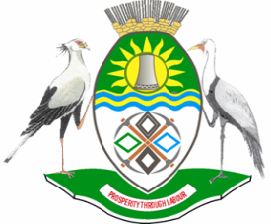

NKANGALA DISTRICT MUNICIPALITY
PUBLIC NOTICE
ADOPTION OF THE FINAL 2023/24 IDP/PMS/BUDGET FRAMEWORK PLAN
Notice is hereby given, in accordance with the Provisions of Section 27(1) of Local Government: Municipal Systems Act, 32 of 2000 that Nkangala District Municipality has adopted its 2023/24 IDP/PMS/BUDGET Framework Plan during a Council meeting of 31 August 2022.
Copies of the Final 2023/24 IDP/PMS/BUDGET Framework Plan can be accessed at www.nkangaladm.gov.za and are available in the IDP Offices of the following:
Municipality | Physical Address
Nkangala District Municipality | 2A Walter Sisulu street, Middelburg, 1050
Thembisile Hani Local Municipality | Stand no 24, Front Opposite Kwaggafontein Police Station  Along R573 (Moloto Road), Empumalanga, 0458
Dr. JS Moroka Local Municipality | 2601/3, Bongimfundo Street  Siyabuswa, 0472
Victor Khanye Local Municipality | Corner Samuel Road & Can der Walt Street  Delmas, 2210
Emalahleni Local Municipality | Administrative Building, Civic Centre  President Street, Witbank, 1035
Steve Tshwete Local Municipality | Municipal Civic Building, Wanders Avenue  Middelburg, 1050
Emakhazeni Local Municipality | 25 Scheepers Street  Belfast, 1100

For further enquiries please contact: Ms S Mtsweni at 013 249 2209/2090 Department of Planning and Economic Development, during office hours: 07H30-16H30

MM SKOSANA
MUNICIPAL MANAGER

