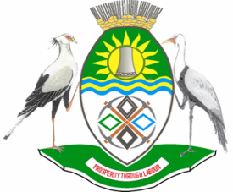

NKANGALA DISTRICT MUNICIPALITY

PUBLIC NOTICE

INVITATION TO THE NKANGALA DISTRICT IDP/BUDGET INDABA 2023/2024

In terms of S30 of the Municipal Systems Act (MSA), the Executive Committee or the Executive Mayor of a municipality must, inter alia, in accordance with S29 of the MSA, submit the draft IDP to the Municipal Council for adoption by the Council. In terms of section 23 (1) of the Municipal Finance Management Act (MFMA), the council must consider the views of the community on the tabled budget.

The Nkangala District Municipality is in the process of finalizing its Draft Reviewed IDP for the 2023/24 financial year and tabled together with the draft budget to council on the 29 March 2023. Subsequent to consultation processes with the communities within the District, an IDP/BUDGET INDABA will be held on the 13th of April 2023. The final IDP will then be tabled to Council for approval on the 26th May 2023 and the final Budget will be tabled in council on the 26th May 2023 for final approval. Therefore, the Honourable Executive Mayor, Cllr LM Mabuza, of Nkangala District Municipality (NDM) is inviting you as a key stakeholder to be part of this process.

The schedule of the meeting is as follows:

VENUE: Nkangala District Municipality Council Chamber
DATE : 13 APRIL 2022
TIME : 10H00

Enquiries may be directed to: Ms. LS Mtsweni at tel: (013) 249 2209 or email mtswenisl@nkangaladm.gov.za during office hours from 07h30 to 16h30.

MM SKOSANA
MUNICIPAL MANAGER

